Phase 5: Deployment, Documentation & Final Presentation

Innovation

1) Purpose
The purpose of highlighting innovation in the metro ticket booking system is to showcase the unique approaches and technical improvements implemented to streamline operations, reduce manual effort, and enhance maintainability. This demonstrates forward-thinking solutions and efficient system design.

2) Automation-Driven Design
A) Flow Designer Utilization
The system leverages Flow Designer to automate end-to-end processes without relying on extensive custom scripts or business rules. This approach ensures that workflows such as catalog variable retrieval, record creation, and notifications execute seamlessly, while keeping the backend logic simple and maintainable.
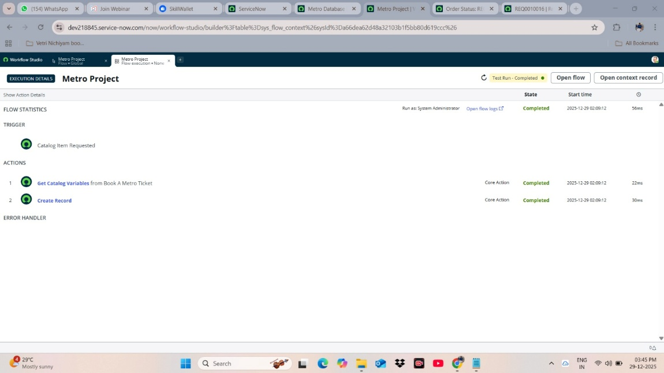

B) Dynamic Task Creation
Dynamic task creation allows the system to generate required backend records and follow-up tasks automatically based on user inputs. This reduces manual intervention, prevents errors, and supports consistent operations across different metro ticket requests.
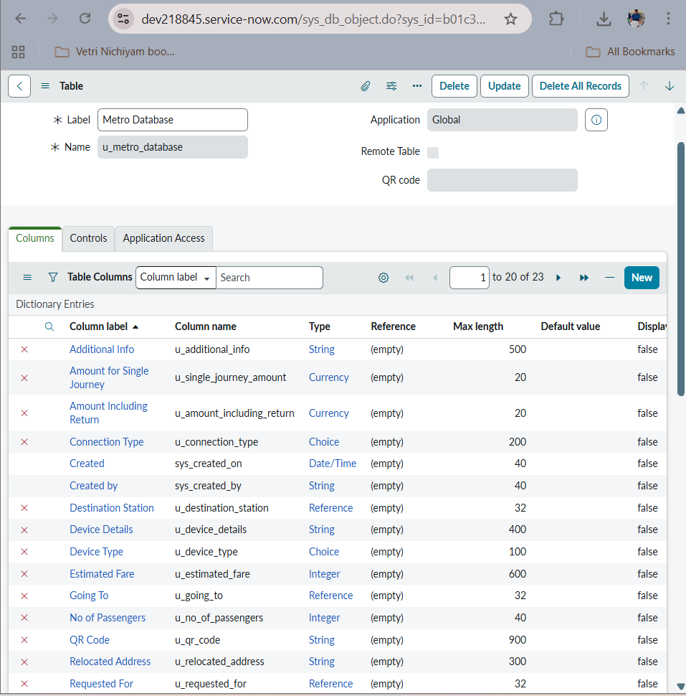

C) Minimal Client Scripts and UI Policies
Client scripts and UI policies are used only where essential, such as dynamic field visibility, fare auto-population, or input validation. By minimising custom scripts, the system remains easier to maintain and simpler for future developers or admins to manage.

3) Maintainability and Handoff
The design emphasizes maintainability, ensuring that future administrators or developers can easily understand, modify, or extend workflows. Documentation, structured flows, and standardised field mappings support efficient handoff without requiring deep technical knowledge of custom scripts.

4) Outcomes
- Reduced reliance on complex custom scripts and business rules
- Streamlined automation across catalog submissions and database updates
- Easy system maintenance and scalability for future enhancements
- Efficient, reliable, and user-friendly ticketing process

